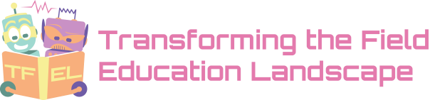
Job posting information

Position type: | Part time
Job title | Student Research Assistant Position – Qualitative Data Analysis
Number of positions | 1
Job Start date | March 20, 2022
Job location | Remote/working from home
Job description | The Transforming the Field Education Landscape: Intersections of Research and Practice in Canadian Social Work Field Education research project, led by Project Director Dr. Julie Drolet, invites application for a Qualitative Data Analysis Student Research Assistant.  This part-time fixed short-term position will be for approximately 3 months with the possibility of extension.  The Data Analysis Student Research Assistant will be responsible for working with the TFEL research team to analyze qualitative data and summarize major themes collected from national study interviews.  The candidate will also contribute to knowledge mobilization activities such as peer-reviewed publications, conference presentations, webinars, workshops, etc. and other duties as required.  Position Description and summary of Responsibilities:  - Thematic analysis of qualitative interview transcripts and determine emergent themes from transcripts.  - Code transcripts using NVivo software.  - Produce a comprehensive data report summarizing emergent themes from the analyzed data set.  - Assist with Knowledge mobilization and integrated knowledge exchange.
Job Requirements | - Registered post-secondary university student (all disciplines).  - Experience with NVivo software.  - Access to a PC Computer.  - Ability to prioritize, plan, and organize own workload to meet demands and deadlines.  - Strong interpersonal skills and the ability to work well in a team.  - Excellent communication via all mediums.  - Ability to work independently and promote good teamwork.
Application Information
Application Deadline: | March 14, 2022, 11:59 PM.
Application procedure | Please send a letter of application, curriculum vitae, any sample of your work related to this post, and names and contact information of two referees by March 14th, 2022 or until the position is filled to tfelproject@ucalgary.ca and Project Director, Dr. Julie Drolet (jdrolet@ucalgary.ca) and Project Coordinator Dr. Emmanuel Chilanga (emmanuel.chilanga@ucalgary.ca).

Dr. Julie Drolet, Professor
TFEL Project Director
jdrolet@ucalgary.ca
Faculty of Social Work, University of Calgary
3-250, 10230 Jasper Avenue, Edmonton, AB, T5J 4P6
Subject Line: TFEL Copy Editor Application – Name

We would like to thank all applicants in advance for submitting their resumes; please note that only those candidates chosen to continue through the selection process will be contacted

